DIGITAL CAMERA
The first digital camera was invented by Steven Sasson in 1975. Digital cameras are normally used to capture still picture or take videos through the use of an electronic image sensor.
- Cameras that we use today are smart and have a lot of features that were not present in early cameras all because of the embedded system used in them.
- A digital camera has basically three functions, to capture an image which we call data, to store image data, and to represent this data.
- There is no need for the film for storing images. This feature has increased the storage capacity and made it easy to transfer images.
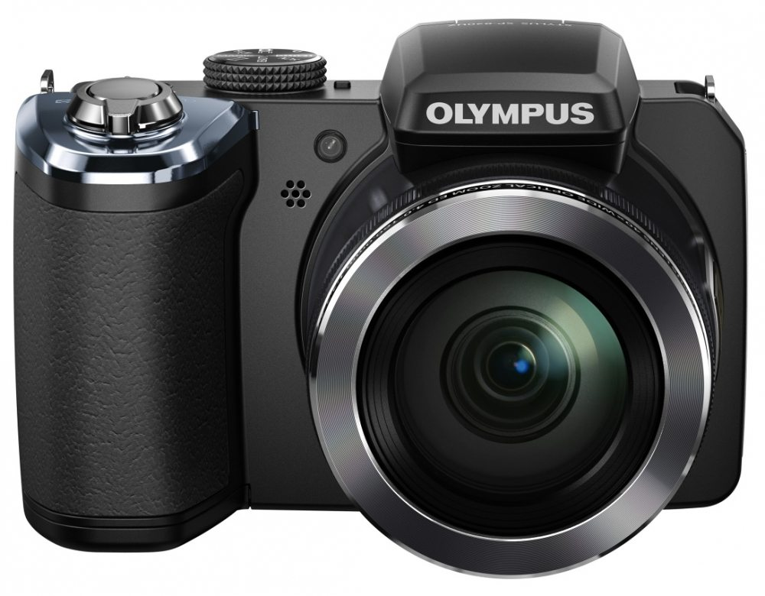
● A digital camera is an example of sophisticated embedded system. It consists of a lot of components including the DSP processors.
● Digital camera includes various types of memories like DRAM, memory card, flash memory with controller etc.
● The CPU is the main processor is also connected with the various other processors. The host processor just controls the various operations and the complicated operations are performed by these task processors.

- The below figure shows one possible block diagram of a digital camera.
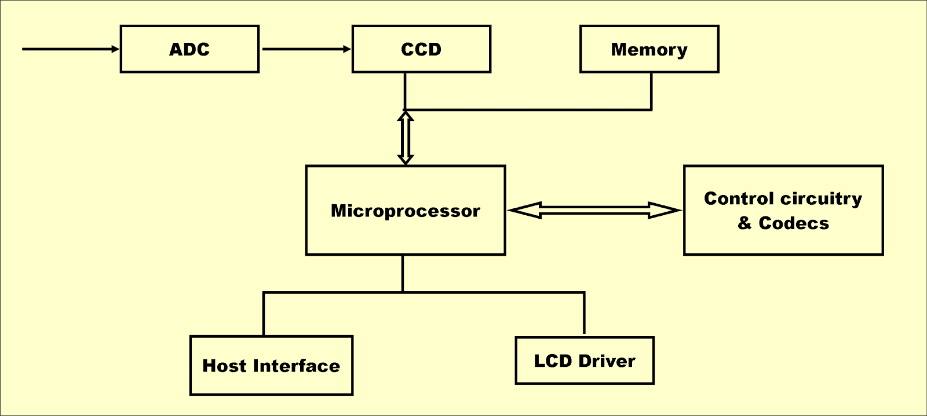
This is how a digital camera works by integrating the hardware components and the software components by using the embedded system.
